Year 3  Where the Forest Meets the Sea |  |  |  |  |  |  | 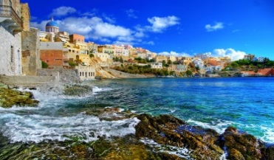
English |  |  | Focus Book: Where The Forest Meets The Sea  This half term the children will be reading a book by Jeannie Baker. We will focus on inference using the very interesting collage pictures. The children will finish the unit by writing a story based on the pattern of the story. The children will develop their knowledge of conjunctions, adjectives, adverbs and using dialogue within a story. Later in the term, we will complete a poetry unit.
Maths |  |  | This half term, we will continue developing our strategies to add and subtract numbers mentally. Following this, we move on to using the column method to add and subtract. Later in the term, we move onto interpreting bar graphs and identifying different angles and types of lines.
Science, Geography and History | Science  Key Questions:  How are shadows created?  Why does the sun change position in the sky?  Why are shadows different lengths?  Why are some shadows darker than others? |  |  |  | History / Geography  Key Questions:  What are the key parts of the globe? EG equator and tropics.  Can we name all of the continents and oceans?  What is the Mediterranean like?  What countries fall in to the Mediterranean?  How does the climate differ from England?
Art and Design  Children will be exploring the images with Where The Forest Meets The Sea. We will look at how the illustrator uses collage to create 3D looking images. Considering this technique, we will create our own collage of a Forest or Beach scene. |  |  |  |  | Computing  The children will be continuing to code and create their own games using Kodu. We will also be discussing how to stay safe online. |  | PE  Dance – The children will be creating their own dance moves to match beach scenes.  Outdoor - They will be introduced to invasion games through netball.
PSHE  The children will be learning about diversity. We start by thinking about ours and others identities. |  | RE  The children will be considering what is important to Jewish people. |  |  | Music  The children be learning how to play the recorder in their music lessons. |  | Languages  The children will securing numbers, family members and greetings in French.
Learning Values | Motivation  Why do people visit the Mediterranean for their holidays? |  |  | Responsibility  Designing and making items in the style of that era. |  | Collaboration  We will work with a learning partner to discuss ideas.  We will be learning to listen to our partner’s opinion and sometimes reach a compromise on our ideas.
 | Perseverance  How do Scientists make their discoveries?  What motivates them to keep trying when things go wrong? |  |  | Discovery  Research using questioning, globes and atlases to justify our reasons. |  | Growth Mindset  The children will look at the strategies to overcome fear of failure when creating their collage.
Where the Forest Meets the Sea
by Jeannie Baker

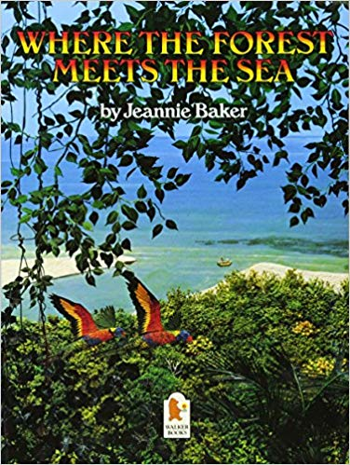
When a young boy visits a tropical rain forest, he pretends it is a long time ago and that extinct and rare animals live in the forest, and aboriginal children play there. But how much longer will the rainforest remain, he wonders?

Other Recommended Reads Linked To This Theme:

Postcards from Crabby Spit by Rowland Harvey
Window by Jeannie Baker

