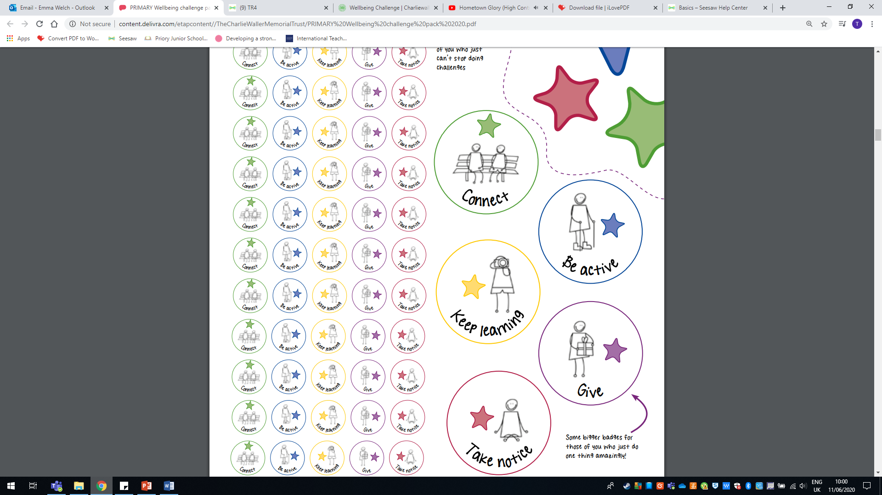

Thank you for taking part in Wellbeing Day.

**Wellbeing Day**

Awarded to:

____________________