Year 6  A Web of Discovery |  |  |  |  |  |  | 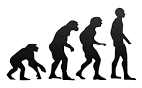
English |  |  | Focus Book: The Lost Thing Shaun Tan  In English we will be exploring the book ‘The Lost Thing’ by Shaun Tan. The children will be exploring the text using narrative, generating exciting vocabulary and considering structure. They will also be writing their own versions of the narrative set in our school. In guided reading we will be exploring non-fiction texts.
Maths |  |  | In Mathematics, the children will be looking at using efficient methods to solve problems involving all 4 operations. They will also be angles and shape!
Science, Geography and History | Science  Have we always looked like this?  Could we possibly have evolved from apes, monkeys or other primates?  Who was Charles Darwin and why is he still a controversial figure?  Can you find out how animals have adapted?  What do fossils tell us about ‘how things have changed’?  Can you use your learning to design your own species? |  |  |  | History / Geography  Where did Darwin Travel?  Where did Darwin travel?  Can you identify the physical features of Australia?  Can you identify the physical features of the UK?  Can you identify the human features of Australia?  Can you identify the human features of the UK?  Can you compare maps of Australia to the UK?
Art and Design  Can you design your own fossil print?  The children will explore different methods of printing. |  | Technology  Viking Hats at the ready! In preparation for our Viking battle, the children will be sewing their own felt helmets! |  |  | Computing  This half term we will be focussing on how the children can stay safe online. |  | PE  The children will develop dance skills through an anti-bullying dance unit. We will also be learning how to work as a team during hickey
PSHE  Through class discussions and circle time, children will be taught how to solve conflicts in a restorative way. |  | RE  Can Science and Religion both be right about creation?  The children will be learning to appreciate the beliefs of others. |  |  | Music  The children will be exploring the music of The Jacksons, with a particular focus on the song ‘I’ll Be There’ |  | Languages  Bonjour!  The children will develop their French vocabulary and converse in full sentences about their home.
Learning Values | Motivation  The exploration of Darwin’s research provides children with opportunities to aspire to be our future scientists.. |  |  | Responsibility  Children will use their learning on evolution to design and present their own new species. |  | Collaboration  Through partner activities in dance, children will learn to work positively and productively.
 | Perseverance  Children will learn to persevere with new challenges. Let’s get threading those needles! |  |  | Discovery  The children will develop the fundamental skills to become super scientists! |  | Growth Mindset  Our growth mindset focus will be on constructive feedback and setting new challenges.

The Lost Thing by Shaun Tan

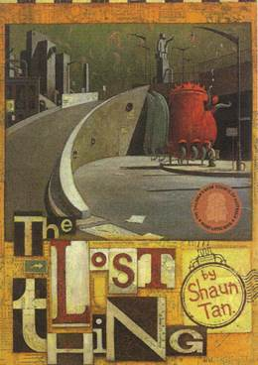
While walking on the beach collecting bottle tops, a boy finds a strange, sad-looking, but friendly, 'thing'. The lost thing (a huge abstract and red object with six legs and many windows and doors) and the boy spend a pleasant time together. Since no one seems to claim ownership of the thing, the boy decides to take it home, but eventually hands it over to a special place where many unclaimed items are left.

Other Recommended Reads Linked To This Theme:
Millions by Frank Cotterell Boyce
Way Home by Libby Hathorn
Holes by Louis Sacher
My Name is Mina by David Almond

