
Priory News
April 2020

Dear Parents,

I hope you all had a restful Easter break and welcome to our very first remote summer term!

We’ve all had to adapt to new ways of working, so I wanted to take the opportunity to say what an amazing job you’re doing supporting your child’s wellbeing and learning during this time.

It’s definitely been a strange and challenging time, so it’s ok if you and your child feel wobbly and worried at the moment. We’re here for you every step of the way as we figure this all out together. Remember, if you have any concerns about helping your child learn or you need any other support from the school, please let us know by emailing the school office – they will forward your email to either your child’s class teacher or a member of the Senior Leadership Team.

We miss the children very much, but we must follow the government’s guidance to keep everyone in our community safe. So, we’re carrying on with providing remote learning for all the children through See-Saw (our new learning platform), and in school provision for children of critical workers and vulnerable pupils.

But just because we’re not all in the same building, doesn’t mean we can’t have some fun together! Your children will have lots of activities they can get stuck into over the summer term – so keep a close eye on See-Saw, where the activities will appear.

We also love seeing the children’s fantastic learning at home – thank-you for sending pictures and emails in. Now we have See-Saw this should make it much easier for us too.

We can’t say yet when we’ll be able to open the school fully, but rest assured that we’ll continue doing our utmost to keep your child learning and our school community connected.

Let’s get cracking with our summer term!

Warm regards,

Tracy Keefe

Term Dates

Summer Term Starts 20th April
VE Day Celebrations (Bank Holiday) 8th May
Half-Term 25th – 29th May
End of Summer Term 22nd July

Autumn Term starts 7th September
Staffing

At the end of the Spring term, we said goodbye to Miss Brain, one of our Play Workers at The BASE. We wish her all the best with her future career.

Parents Evenings – 20th and 22nd February

This round of Parents’ Evenings is a good time to catch up with your child’s class teacher about the progress they are making so far this year, and to find out what the next steps in learning are for your child.

Should you have missed booking an appointment, please contact your child’s class teacher – who will be happy to make a time to meet you at the end of a school day.

Pupil Progress Reports

The teachers have collated all their Spring term assessments, and these have now been emailed to all parents in the form of our Spring Term Progress Report. We hope you find this information useful.

This report will detail current teacher assessments for reading, writing and maths, alongside an indication of effort too.

Sports Relief – 13th March

Thank-you for all your donations for Sports Relief. Together, we raised £140.77
Sharing Assembly – 20th March

On our final Sharing Assembly on 20th March, all classes were awarded with the Headteacher’s Award. It was a celebratory but poignant assembly. We would usually take a photograph of the children who had been awarded their certificates that week for our board in the hall. Instead we took a whole-school selfie of the awards.

This is the picture below:

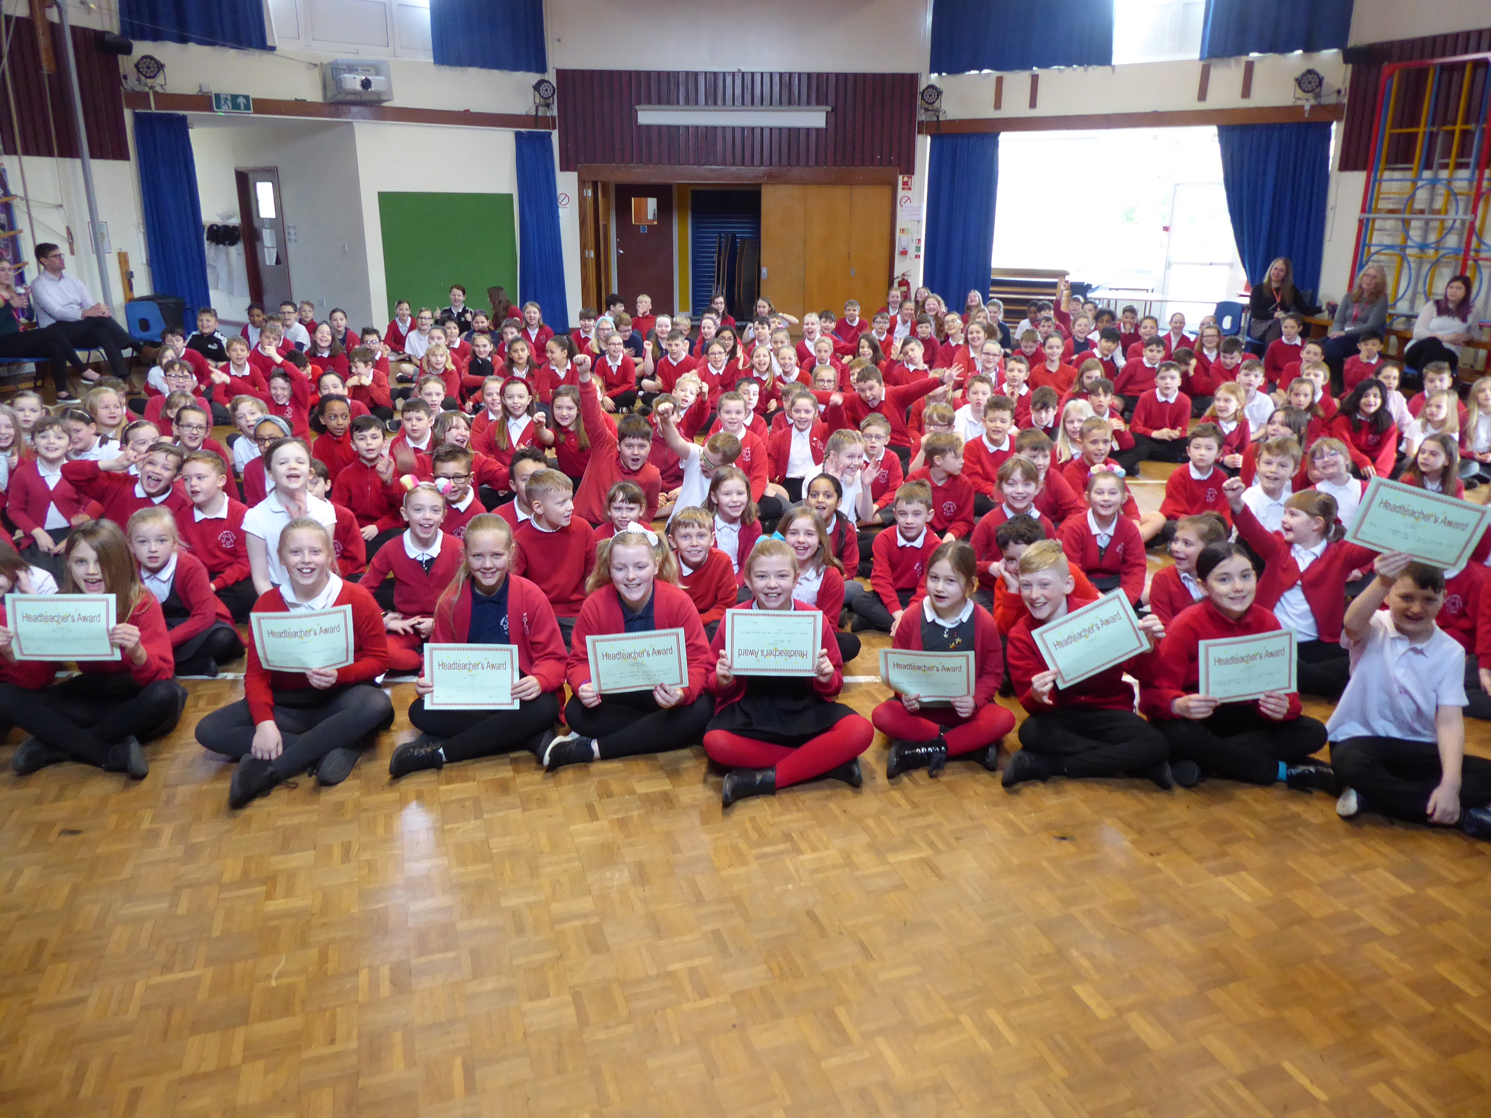

Class Photographs

We were planning to have the photographer in school on 23rd April, but clearly this won’t be taking place. However, we took our own class photographs on the 20th March, just before school closed. We will be emailing these to parents this week – please keep a look out for them. We hope they will provide you with a small record of your child’s class this year.
However, we appreciate we had a lot of children (and staff) missing so have a suggestion of how we can improve this further. Please look out for a letter about this.
See-Saw

Hopefully, you have now been able to access See-Saw – it has been fantastic to see your children’s learning taking place using this tool. Each day your child will have a different English and Maths activity to do. These will appear each day. Other subjects will be arrive on See-Saw each Monday for the week – you can choose when / how you organise your time to complete these.

Some subjects (eg. Technology) will have a choice of three activities to do – you don’t need to do all three, but can choose one to do.

To help families with supporting children in different year groups, we have chosen a whole-school theme of ‘Weather Warriors’ – the foundation subjects learning activities will be linked to this theme.

If you have any questions about See Saw, or need a little help, please let the school know through emailing the office. We will be in touch to help you out.
Sunflowers of Hope

We hope your child has now received their sunflower seeds. We would very much like them to plant these seeds and grow some sunflowers of hope this summer.

It would be great if they keep some records of this too – drawing, photographing, measuring height, recording growth. We will keep this open for your child to decide how to do this.
Free School Meals

At this challenging and uncertain time, we know that families may find themselves in a circumstances that have changed, including financial situations.

This may mean that you become eligible to be supported through Free School Meals. You can apply online at www.cambridgeshire.gov.uk/freeschoolmeals
Please see the letter that was sent home this week about the criteria for this.

As a school, we are supporting all families with supermarket food vouchers, if they are eligible for free school meals. If we can support you in this way, please do apply online.

We will then make sure you receive vouchers to support you too.

NSPCC

The NSPCC have produced a local newsletter, which we will send with this newsletter.

There are some good ideas for supporting children at this time in this, including keeping children safe online, and places that parents can go to for support too.
In-School Support

Days within school are rather different at the moment.

For those of you at home wondering what it is like in school at the moment, we have a small number of children who join us each day in school.

Our teaching team are working in school on rotation – with very few staff in school on any given day. This allows us to keep our staff as safe as possible at this time, and also allows them time to prepare learning activities and respond to See-Saw learning while they are at home.

We miss you all, and look forward to the days when school may feel a little more like normal.

VE Day Celebrations

8th May marks the 75th Anniversary of VE Day, and you will know that the May Day Bank Holiday was moved to Friday, 8th May so that the nation could commemorate this.

So, what can you do now? There is a call around St Neots to join the town in self-isolation picnics in your garden at 1pm on Friday, 8th May to mark this, and to dress in red, white and blue too.

If you do, we would love to share some pictures of your celebrations on our next newsletter. Please email them in to us.
Please keep safe and stay well.
We look forward to seeing you all again, when times allow.
Fundraising Stars…..

It is heart-warming to hear of children who are busy fund-raising for charity at this time.

Sam in DF4 is going to let his dad cut his hair for Sue Ryder during lockdown. He has been very proud of his growing hair and is very nervous about losing it all, especially as there are no hairdressers open! Visit his page here: https://www.justgiving.com/fundraising/samfrench11?fbclid=IwAR3Xl08nfQ-7oz1VYNFUA55gAFYEJjkZ58lHFfgQ0ISrFqNrThNuvNVkLL0

Freddie in DF4 is going to walk a marathon over the period of 2 weeks to raise money for Friends of Priory. See his page here.
https://www.gofundme.com/f/freddies-marathon-walk-in-2-weeks?utm_source=customer&utm_medium=copy_link&utm_campaign=p_cf+share-flow-1

