Year 4  A Golden Age |  |  |  |  |  |  |  |  | 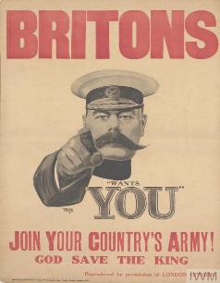
English |  |  | Farther by Grahame Baker-Smith  This half term, we are looking forward to exploring the beautifully illustrated picture book Farther. As a class, we will be studying the themes and messages the book portrays with a particular focus on the importance of perseverance and determination. We will also be looking more closely at the complex relationship between the key characters through role play and drama. Key writing skills will be explored in the context of the book and will cover: expanded noun phrases to create effective character descriptions; fronted adverbials to show where, when and how an event has occurred and direct speech. Our long term aim is to create an engaging sequel to this spellbinding book.
Maths |  |  | In mathematics, we will revise aspects of geometry including categorising shapes according to their properties, and comparing the size of angles. We will also be looking at fractions and word problems, and applying all these into mathematical investigations. We will also be studying and developing our understanding of fractions and decimals.
Science, Geography and History | Science  Key Questions:  What was life like for a child 100 years ago without electricity?  Why have we become so dependent on electricity?  How could you create a torch using an electrical circuit?  Can I read and interpret a circuit diagram?  What are conductors and insulators and how do they make components work?  How does the on and off switch work on an electrical component? |  |  |  |  | History / Geography  Key Questions:  What did children play with for entertainment 100 years ago?  What was it like to be a school child in 1917?  Why was leisure and entertainment different for the wealthy in comparison to the poor?  How has technology changed the way children learn at school and at home?  What was a silent movie and why were they popular?  How could you create your own silent movie?
Design and Technology  In design and technology the children will be creating their own torches. This will involve testing designs and circuits. |  |  |  | Computing  The children will be creating their own comic strips based on the events from 100 years ago. |  |  | PE  The children will be exploring invasion games. Indoors we will look at control, balance and collaboration as the children take part in vaulting and sequences
PSHE  The children will be exploring how to stay safe around electricity |  | RE  In R.E. the children will be looking at the symbolism in light throughout different religions. This will include the festival of Diwali. |  |  |  | Music  The children will be learning to play and composing music, using the glockenspiels. |  |  | Languages  French: The children will be revising work on animals before moving on to looking at food
Learning Values | Motivation  The children will be aspiring to be the best they can be in PSHE, looking at different choices they could make to ensure they live a healthy lifestyle. |  |  |  | Responsibility  The children will become torch developers, deciding on their own look, style and how it will work. |  |  | Collaboration  Making torches require lots of ideas and different people performing their tasks well to be successful – the children will be a design team to create the best and brightest.
 | Perseverance  During P.E. children will need to persevere with skills and team work in order to be successful. Gymnastic sequences take lots of attempts, tries and mistakes before the final performance is ready for competition! |  |  |  | Discovery  Children will be using a range of sources such as the internet and our library to research and learn more about what life was like as a child 100 years ago. |  |  | Growth Mindset  The children will be developing their resilience in their learning and their approach to constructive criticism – looking at how mistakes can help us become better learners.

Farther
by Grahame Baker-Smith

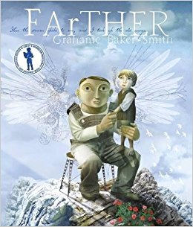

My father’s house was safe and rooted in the rock. But inside he dreamed of air and flight…
Step into an incredible world, where dreams that are passed from father to son make anything possible.
Other Recommended Reads Linked To This Theme:
War Game Village Green to No-man’s Land by Michael Foreman
Where the Poppies Now Grow by Hilary Robinson and Martin Impey
The Christmas Truce: The Place where Peace was Found by Hilary Robinson and Martin Impey

