Spellings – words with the /u/ sound spelt ‘o’
Read the words below with an adult. Can you identify where the letter ‘o’ actually makes a /u/ sound?
Practise spellings these words using the look, say, cover, write, check method.
Woman
Wonder
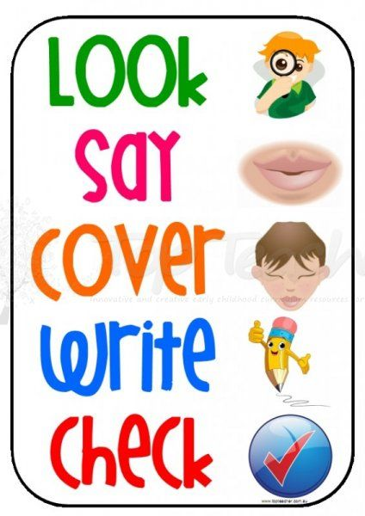
Mother
Brother
Another
Month
Discover
Monday
Shovel
Above
Money

