Year 5
Journey to Jo’Burg
English |  |  | Focus Book: Journey to Jo’burg by Beverley Naidoo  This is a story about the apartheid in South Africa – it will link to narratives and recounts. To develop the children’s reading, we will be exploring the thoughts and feelings of characters in different situations and from diverse cultures.  To develop the children’s grammar, we will be focusing on expanded noun phrases, similes, metaphors and personification. We will also explore sentence openers, power of three and relative clauses. We will be discussing the key historical events surrounding the apartheid.
Maths |  |  | In Mathematics, the children’s understanding of fractions will be developed. They will also develop their formal methods for multiplication and division. We will be solving problems looking for key facts. Children will also be interpreting negative numbers and exploring properties of number.
Science, Geography and History | Science  How different will you be when you are as old as your grandparents?  Can children explain how the gestation period relates to mass in humans and other animals?  Can children explain how we change as we grow older?  Can you explain a scientific idea and what evidence supports it?  Can children find a pattern in their data and explain what it shows? |  |  |  |  | History / Geography  Key Questions:  Where is South Africa?  What was it like to be black during apartheid?  What are the key events and changes that happened during Nelson Mandela’s life?  Who are the ANC?  What was the Soweto uprising?  How can we relate the Soweto uprising to other historical events in Britain?  Can you compare racism during apartheid to modern day in Britain?
Art and Design  We are appreciating South African art and using this as inspiration to create our own interpretations in this style. |  |  |  | Computing  We will be using multimedia to create African Stories with sound effects  Handling data: logging data  e-Safety: we will be exploring how to keep safe when downloading |  |  |  | PE  Swimming  Dance: creating African themed animal dances.
PSHE  Diversity and Communities.  Link to The Long Road to Freedom topic. |  | RE  Exploring the Nativity - Jesus the Messiah. Understanding Christianity – what is incarnation? |  |  |  | Music  The children be learning all about Jazz and creating some funky sounds! |  | Languages  French  My home;  Language based on a home theme eg. words for kitchen, bathroom
Learning Values | Motivation  We will be inspired by the achievements of Nelson Mandela. |  |  |  | Responsibility  Understand how putting an end to apartheid has helped us to strive for equality for all. |  | Collaboration  We will work with a learning partner to discuss ideas.  We will be learning to listen to our partner’s opinion and sometimes reach a compromise on our ideas.
 | Perseverance  What motivated Nelson Mandela to keep on fighting for freedom despite the challenges he faced? What does his life tell us about perseverance? |  |  |  | Discovery  We will investigate the past and find evidence to support our reasoning. |  | Growth Mindset  We will be focussing on resilience and perseverence to support our learning.

Journey to Jo’burg
by Beverley Naidoo

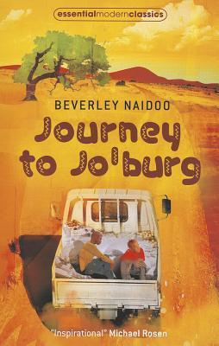

Mma lives and works in Johannesburg, far from the village thirteen-year-old Naledi and her younger brother, Tiro, call home. When their baby sister suddenly becomes very sick, Naledi and Tiro know, deep down, that only one person can save her. Bravely, alone, they set off on a journey to find Mma and bring her back.
Other Recommended Reads Linked To This Theme:

The Long Walk to Freedom (children’s version)
Out of bounds by Beverley Naidoo

